ANNEX B
NJC H1 Maths Preliminary Examination

Qn/No | Topic Set | Answers
1 | Integration Techniques, Definite Integrals | - 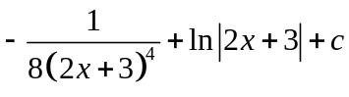  - 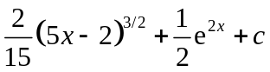  - -2.93
2 | Differentiation, Integration (Area) | 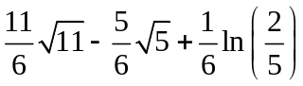
3 | Graphs, Differentiation (Gradients) | 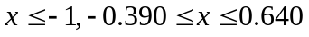  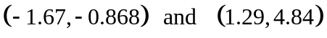
4 | Quadratic Equations, Simultaneous Equations | 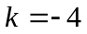;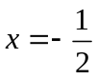;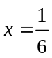,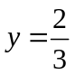
5 | Differentiation (Rates of Change), Differentiation (Tangents and Normals) | 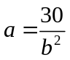; 0.137; -1.257
6 | Probability | 0.46; 0.86; 0.5; 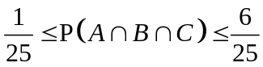
7 | Hypothesis Testing | 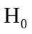: μ = 19.6  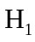: μ > 19.6  Reject.
8 | Binomial Distribution, Normal Approximation to Binomial Distribution | 0.748; 0.924; 0.0157
9 | Correlation & Regression | v
  u
v
u

r = −0.991; x = 10.5; 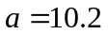, 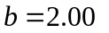
10 | Sampling Methods, Sampling Theory | 12, 2.04, sample variance is 2.
11 | Normal Distribution, Binomial Distribution | 0.310; 0.117; 0.129; 0.0143; 0.0339; 120, 32

